DMC sample HMI

1. Remove old references.

1. Add new references from installed DMC version.

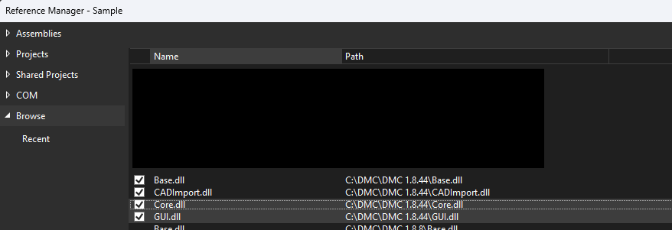

1. Set project output path to installed DMC version.

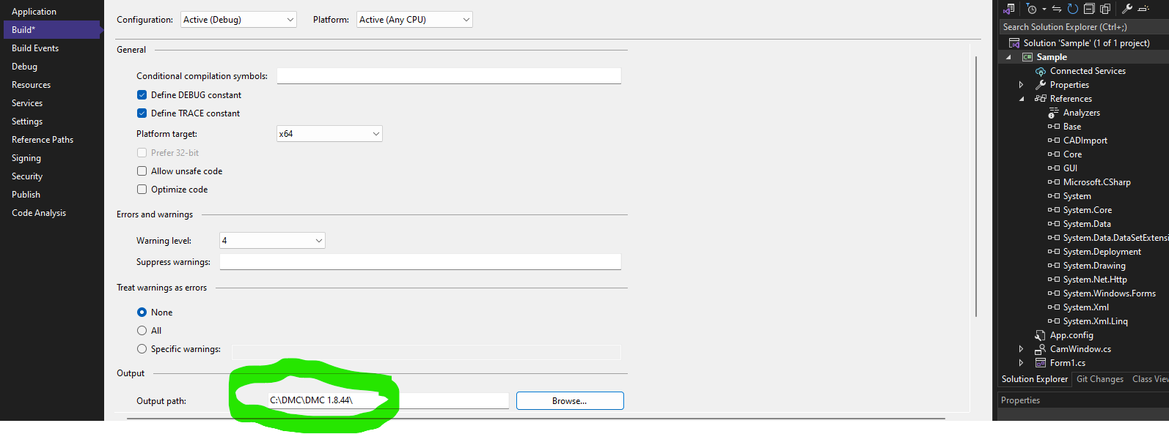

1. Run project

EDIT tab. Allows to import dxf model, edit parameters, see preview window.

CONTROL tab. Allows to move axes in freemove and step mode. This tab includes real-time camera view



